Lab 7 Worksheet Geologic Structures
Name ______ (-2 points if missing)
Date _______
Use your textbook, lab and lecture PowerPoints, and internet as needed to answer all questions in each of the 2 parts. Please explain everything in your own words.
Part 1
- In a tensional regime, would we find more normal or more reverse faults, and why?
a. tension causes normal faults due to the outward motion of the hanging wall blocks leading to the expansion of the Earth’s crust.
- Would we find reverse faults in a compressional regime or tensional regime, and why?
a. Reverse faults are usually found in the compressional circumstances due to the outward motion of the hanging wall block allowing more compression on the crust.
- What is the difference between a normal fault and a reverse fault?
In a normal fault, the blocks of the wall hunging experience the upward Movement relative to the footwall while in a reverse fault, the hanging wall blocks Moves down relative to the footwall block.
- What is the difference between anticlines and synclines?
a. anticlines curve upwards folding of the sedimentary strata while the synclines, usually found along with anticlines, are down folds in the strata.
- What is the difference between in the rock unit age relationship between domes and basins?
a. Difference of the two is that, the center of the dome is made up of the oldest rocks with the Yong rocks on the outer edges as a result of erosion of the top of the dome. Whereas in a basin, the youngest rocks are in the center with the oldest rocks on the outer edges as a result of erosion on the edges as opposed to the sunken center.
- Describe a strike slip fault. Provide an example of one.
a. A strike slip is a fault in which plates Move horizontally to the direction of the fault surface. This is evident in San Francisco earthquake of 1906 of which people’s fences were lifted about 15 feet.
- Of the previously described structures, which are the result of brittle deformation?
a. Fault, such as Oblique fault, reverse fault, strike slip faults together with the normal faults are the result of brittle deformation.
- Of the previously described structures, which are the result of ductile deformation?
a.synclines, anticlines, domes, monocline and the basins are as a result of the ductile deformation.
- Using the diagrams below, which of these are the result of brittle deformation?
a. h, f, d, g and b
- Which of these diagrams are ductile deformation?
a.i, e, c, a and i

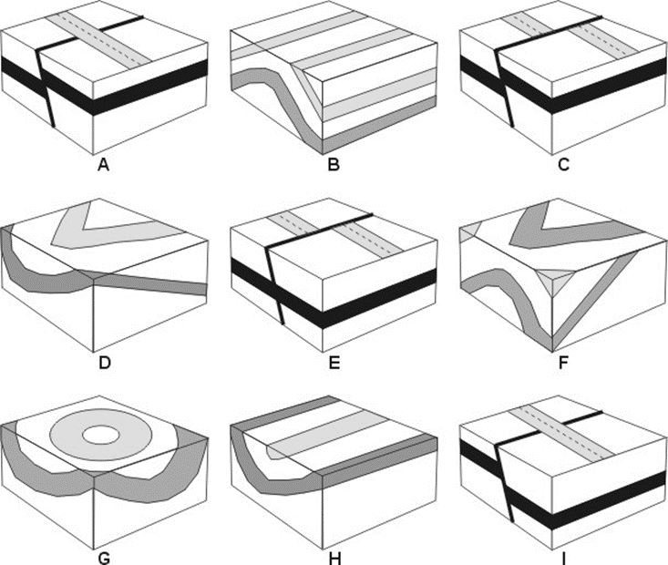

- In the diagrams above, identify each structure.
  - Reverse fault
  - Asymmetric anticline
  - Oblique fault
  - Asymmetric syncline
  - Strike slip fault
  - Monocline
  - basin
  - Symmetrical syncline
  - normal fault

Part 2
- Matching. Use the strike and dip notation in the right column, and match each to a strike and dip symbol in the left column. Type the number in the middle column (be sure you review the lab ppt before doing this part).
 | Which number matches the diagram? | Choose from here
A | 4 | 1. N45E
B | 1 | - N60W
C | 3 | - N10E
D | 5 | - N45W
E | 1 | - N30W

- What type of faults are seen in the side view image below?
  - 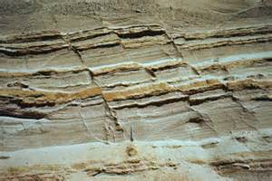
  - Normal fault
- What type of fault is seen in the side view image below?
  - 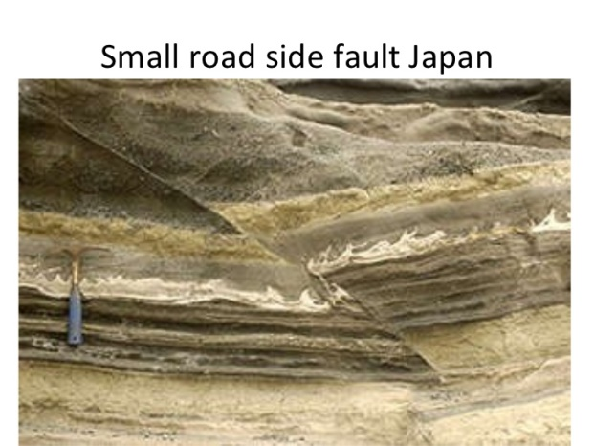
  - Strike-slip fault
- What type of fault is seen in the aerial view below?
  - 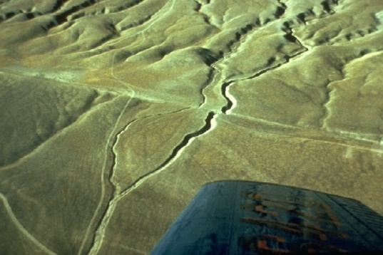
  - San Adreas fault
- What type of fault is shown here?
  - 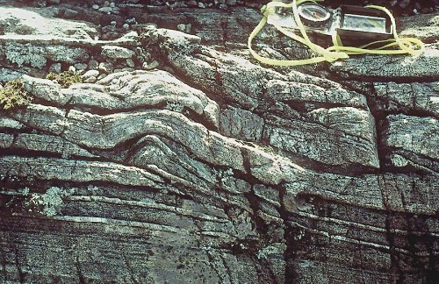
  - Oblique-slip fault
- What type of fold is this?
  - 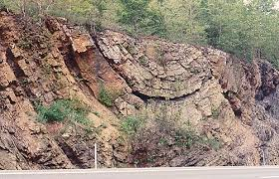
  - syncline
- In the image below, the greenish unit is older than the pink units. What structure is shown here?
  - 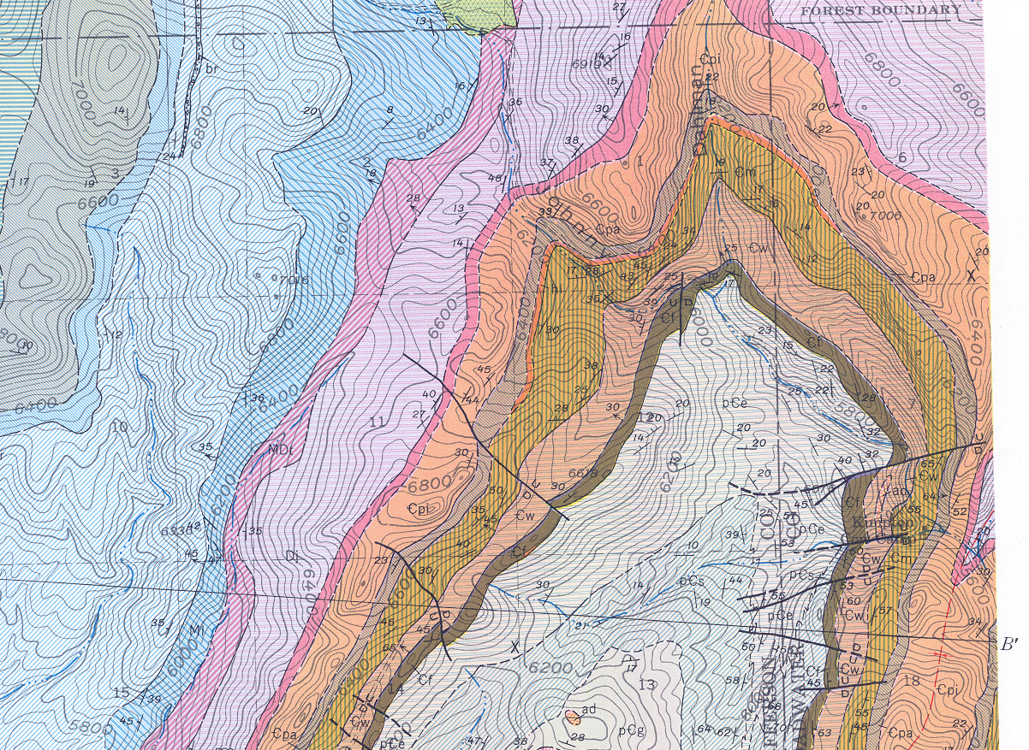
  - volcano
- What is a thrust fault?
  - Is a dip-slip fault in which the upper block above the fault plane Moving up and over the lower block.
- What types of places do we find multiple thrust faults?
  - Places where one plate is being subducted under a nother.example is japan
- What map symbols is this?
  - Compass direction

